A use case is “represents the steps in a specific business function or process.” (Shelly,RosenBlatt, 2012). A use case uses an external entity or actor to portray how the system will beused by the user. Use cases provides tools for capturing functional requirements as well asproviding a starting point for identification of data objects or entries. The use case for a customerwithdrawing money from the ATM service will require several steps in order to reach thecompletion. The use case actor in this particular use case will be the customer. This will describethe process in which the actor (customer) will use his/her ATM card to withdraw money from theATM. This process with include the customer entering their ATM card into the ATM machineand withdrawing money from the bank. Successful completion of this use case will include thecustomer correctly entering their card and pin number, withdrawing the correct amount of cash,the bank transferring the cash to the customer, and the customer’s account being debited theamount of cash that is being withdrawn from the ATM machine. The precondition is that thecustomer’s ATM card must be correctly matched with the pin number for that card in order toproceed with the withdrawal. The post condition is that the customer’s account must be updatedwith a debit of the cash withdrawn from the ATM machine. There are no assumptions in this usecase because several factors must be met including the correct entry of the pin number as well

Another huge concern using ATM is anyone who owns credit or debit cards can easilyaccess to the system without customer’s authentication. There was a survey that one ofthe many reasons of bank fraud has been reported that mainly the theft linked to stealing

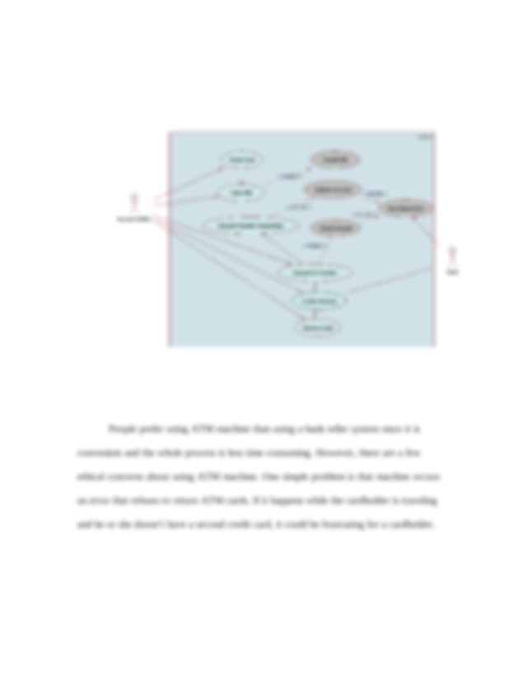

This ***preview*** has intentionally ***blurred*** sections. ***Sign up*** to view the full version.

[**View Full Document**](https://www.coursehero.com/registerForm.php?reg_only=1&get_doc=18162494)

of customer money from the ATM machine (Mall, 2004). A cardholder should not sharePIN numbers with any other person even with the family members. The development ofupdated technology makes the people’s life easier and gives a lot of benefits and also itbrings side effects sometimes. System hackers attempt to break down the server andaccesses on individual information. Also, they can easily duplicate someone’s credit cardand ATM machine authenticates the cardholder without checking who they actually are(Alexander & Maiden, 2004). To solve the security issue, the level of security of ATMmachine should be upgraded as soon as possible.



ReferencesAlexander, I., & Maiden, N. (2004).Scenarios & use cases: Stories through the systemlife-cycle. Hoboken, NJ: John Wiley.Cockburn, Alistair. (2010): Writing Effective Use CasesHegering, H. , Abeck, S., Neumair, B. (1999). Integriertes Management vernetzterSysteme : Konzepte, Architekturen und deren betrieblicher Einsatz. Heidelberg: dpunkt-Verl.. ISBN 3-932588-16-9.Krunchten, Philippe. (2004): The Rational Unified Process: An Introduction. ThirdEdition, Canada: Pearson education, INCMall, R. (2004).Fundamentals of software engineering. New Delhi: Prentice-Hall ofIndia.Shelly, Rosenblatt. (2012). Systems Analysis and Design (9th ed.). Boston: ThomsonCourse Technology.

